**Quick Note: Correction In Next Video**

Hey everyone!

Just a quick note for the next couple of lectures which mention/show the "Anatomy of a NumPy Array" slide.

The code and concepts in the lectures are all correct, however, the slide displays the wrong array for the 3-dimensional array (you'll see these in the upcoming videos).

The correct slide should be:

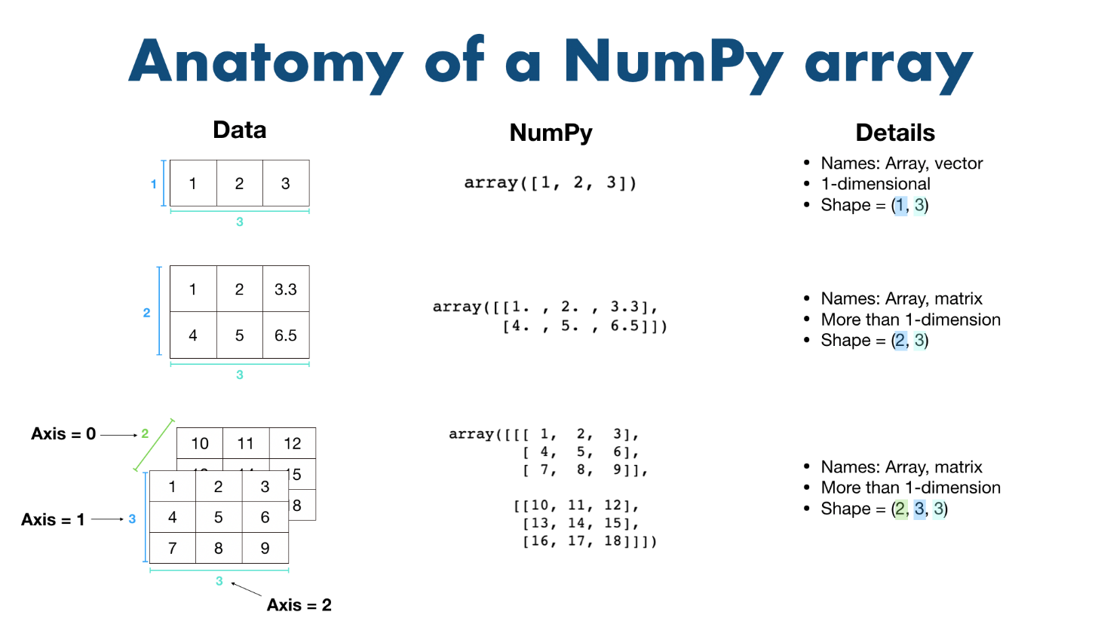

The main difference is the bottom left array. In the videos it's displayed incorrectly.

If you'd like to get the same array as the "Anatomy of a NumPy Array" slide shows in the following videos, run the following code:

1. # Same array as slide in video
2. a3 = np.array([[[1, 2, 3],
3. [4, 5, 6]],
4. [[7, 8, 9],
5. [10, 11, 12]],
6. [[13, 14, 15],
7. [16, 17, 18]]])

And just another reminder, figuring out the different shapes of arrays can be a bit of a challenge! It takes a fair bit of practice to get used to them.

Feel free to leave a question if you need a hand with anything.

A big thank you to @WoWi for pointing out the mistake.

- Daniel